CCT College Dublin

Assessment Cover Page

Module Title: | Strategic Thinking
Assessment Title: | CA 2 – Capstone Project Proposal
Lecturer Name: | James Garza
Student Full Name: | Karina Francieli Schmidt
Student Number: | 2023314
Assessment Due Date: | 17^{h} December 2023
Date of Submission: | 17^{h} December 2023

Declaration

By submitting this assessment, I confirm that I have read the CCT policy on Academic Misconduct and understand the implications of submitting work that is not my own or does not appropriately reference material taken from a third party or other source. I declare it to be my own work and that all material from third parties has been appropriately referenced. I further confirm that this work has not previously been submitted for assessment by myself or someone else in CCT College Dublin or any other higher education institution.

An analysis of the number of the Social Welfare working age recipients in Ireland since 2014 and its possible correlation with the Unemployment rate

By

Karina Francieli Schmidt - 2023314

Higher Diploma in Data Analytics for business
Strategic Thinking
James Garza
CCT College
Dublin, Ireland

ABSTRACT

In the wake of the pandemic, which caught the world off guard, individuals of working age found themselves compelled to exit their employment—either during the pandemic or even in its aftermath—due to widespread layoffs. In response to this crisis, the Irish government implemented measures to ensure the fulfillment of at least the fundamental needs of its citizens.

Consequently, a considerable number of individuals sought government subsidies to sustain themselves through the period of crisis. This report is designed to scrutinize the patterns exhibited by government subsidies both prior to and amid the COVID-19 pandemic, as well as in its aftermath.

Table of Contents

ABSTRACT 3
INTRODUCTION 5
DATA UNDERSTANDING 5
DATA PREPARATION 9
MODELING 11
EVALUATION 12
DEPLOYMENT 12
REFERENCES 13

Tables of Figures

Figure 1 - Head of dataset 8
Figure 2 - Shape and info of the dataset 8
Figure 3 - Describe of the dataset 9
Figure 4 - Visualization of missing values 1 9
Figure 5 - Visualization of missing values 2 10
Figure 6 - Select rows 11
Figure 7 - Drop columns 11
Figure 8 - Label encoder 12
Figure 9 - Summary statistics 12

INTRODUCTION

The social protection program, as in most countries around the world, is created to provide financial incomes to its beneficiaries due the fact that, for many reasons, they are facing unemployment status (Commission on Taxation and Welfare Secretariat 2021). What is usually questioned about these types of programs is, how far the government incentives are helping than to be out of the poverty position and not increasing the rate of working age unemployment group¹ (Bargain and Doorley 2016).

Many countries have taken measures to support workers and businesses during the COVID-19 pandemic. The European Union was one of the economic blocs that offered payments to its citizens, who suffered from restrictions during the pandemic. In Ireland, this subsidy package was called the Pandemic Unemployment Payment (PUP), where weekly payments were made to those who were in some way economically harmed by the pandemic. This government plan began in March of 2020 and was to be finished in February 2022 (Keane et al. 2021).

The relevance of this project is to suggest a data prediction, based on past numbers, and added to this, aims to bring the discussion if the social payments for the working age group, can be affecting the incentive of them to work, especially for young people (Keane et al. 2021). We can see other countries around the world have the same concern, as (Bargain and Doorley 2016) questioned if a possible long-haul poverty status for those who had been incentivized to stay with the incomes provided by the Social Programs in France once the schemes would be extended for the young people under 25 years old.

DATA UNDERSTANDING

The next step conhecido como data understanding, na metodologia de CRISP-DP, é necessária para compreender de modo detalhado os dados relevantes, envolve a avaliação da qualidade dos dados, a identificação de possíveis desafios e a confirmação de que os dados atendem aos requisitos específicos do projeto, assim evitando erro e problemas futuros. dados é fundamental para orientar as etapas subsequentes do processo (Maddux, 2010).
In this project, the dataset chosen, called "Recipients", is available on the Government of Ireland's website. This analysis covers the period before, during and after COVID-19, from 2014 to 2023.
After importing the dataset, the ".head(). function allows you to visualise the data from the first few rows. In this specific case, it will display the first 33 lines, where it is possible to see the existence of different ‘programme’ in row 2.

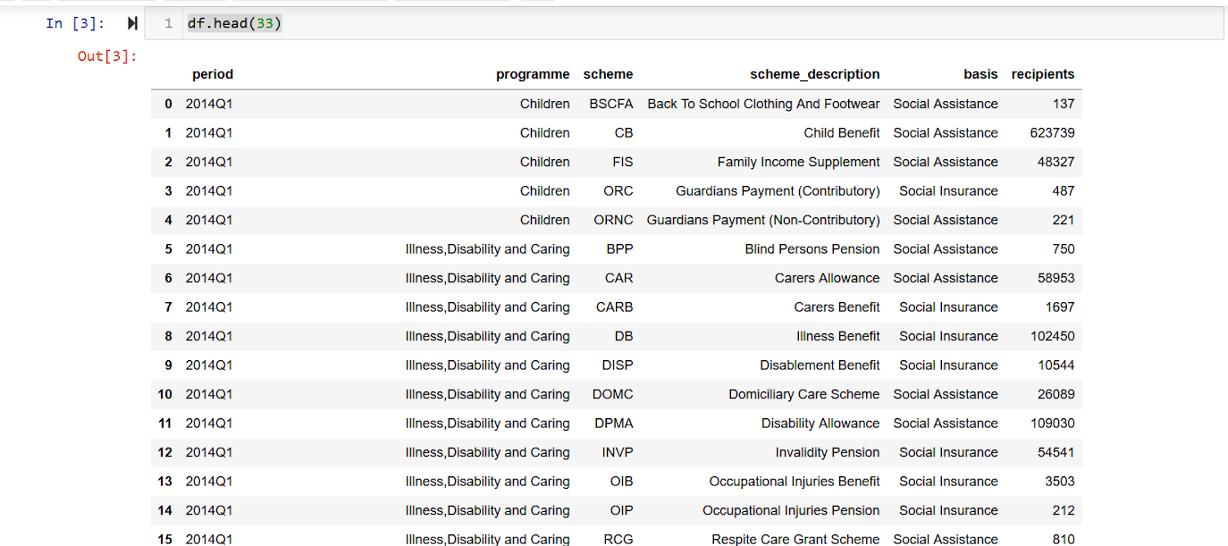
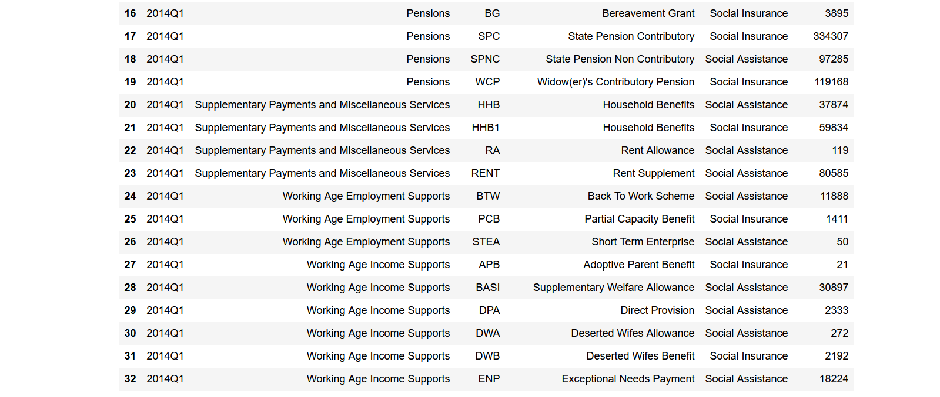
Figure 1 - Head of dataset

Meanwhile, using the ".shape" and ".info" functions, it's possible to get a better view of the information in the data. This shows that there are 1647 rows and 6 columns, indicating object, that five present categorical values and there is one column with integer values (int64).

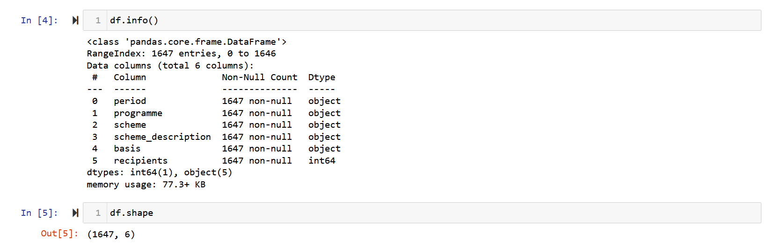
Figure 2 - Shape and info of the dataset

Then, using ".describe(), descriptive statistics summarising the distribution of damage were generated in the column with numerical data. The non-numerical data will be converted later for the use of machine learning. With the numbers shown in the recipients column
The relationship between mean and standard deviation is an indication of the distribution of the data. In this dataset, the mean is lower than the standard deviation, which shows that the values are dispersed, i.e. the individual values deviate from the mean.

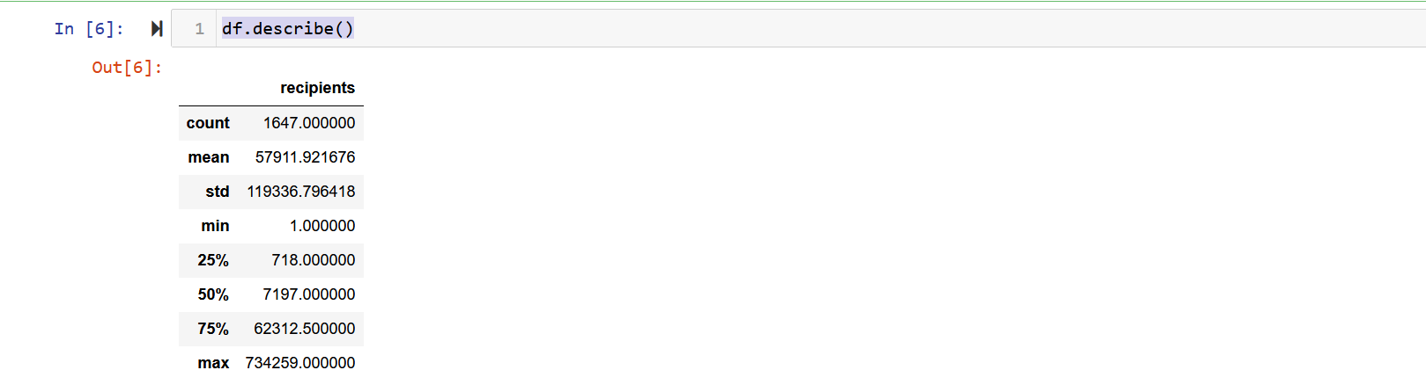
Figure 3 - Describe of the dataset

To summarise, the bar chart generated by this code provides a visual representation of the presence of null values in various columns of the new_df DataFrame. Each vertical bar corresponds to a column, and the height of the bar indicates the proportion of null values in the respective column. If the bar is completely filled, this indicates the total absence of null values in the corresponding column. This type of visualisation is useful for identifying patterns of missing values and understanding which columns have the most missing data.

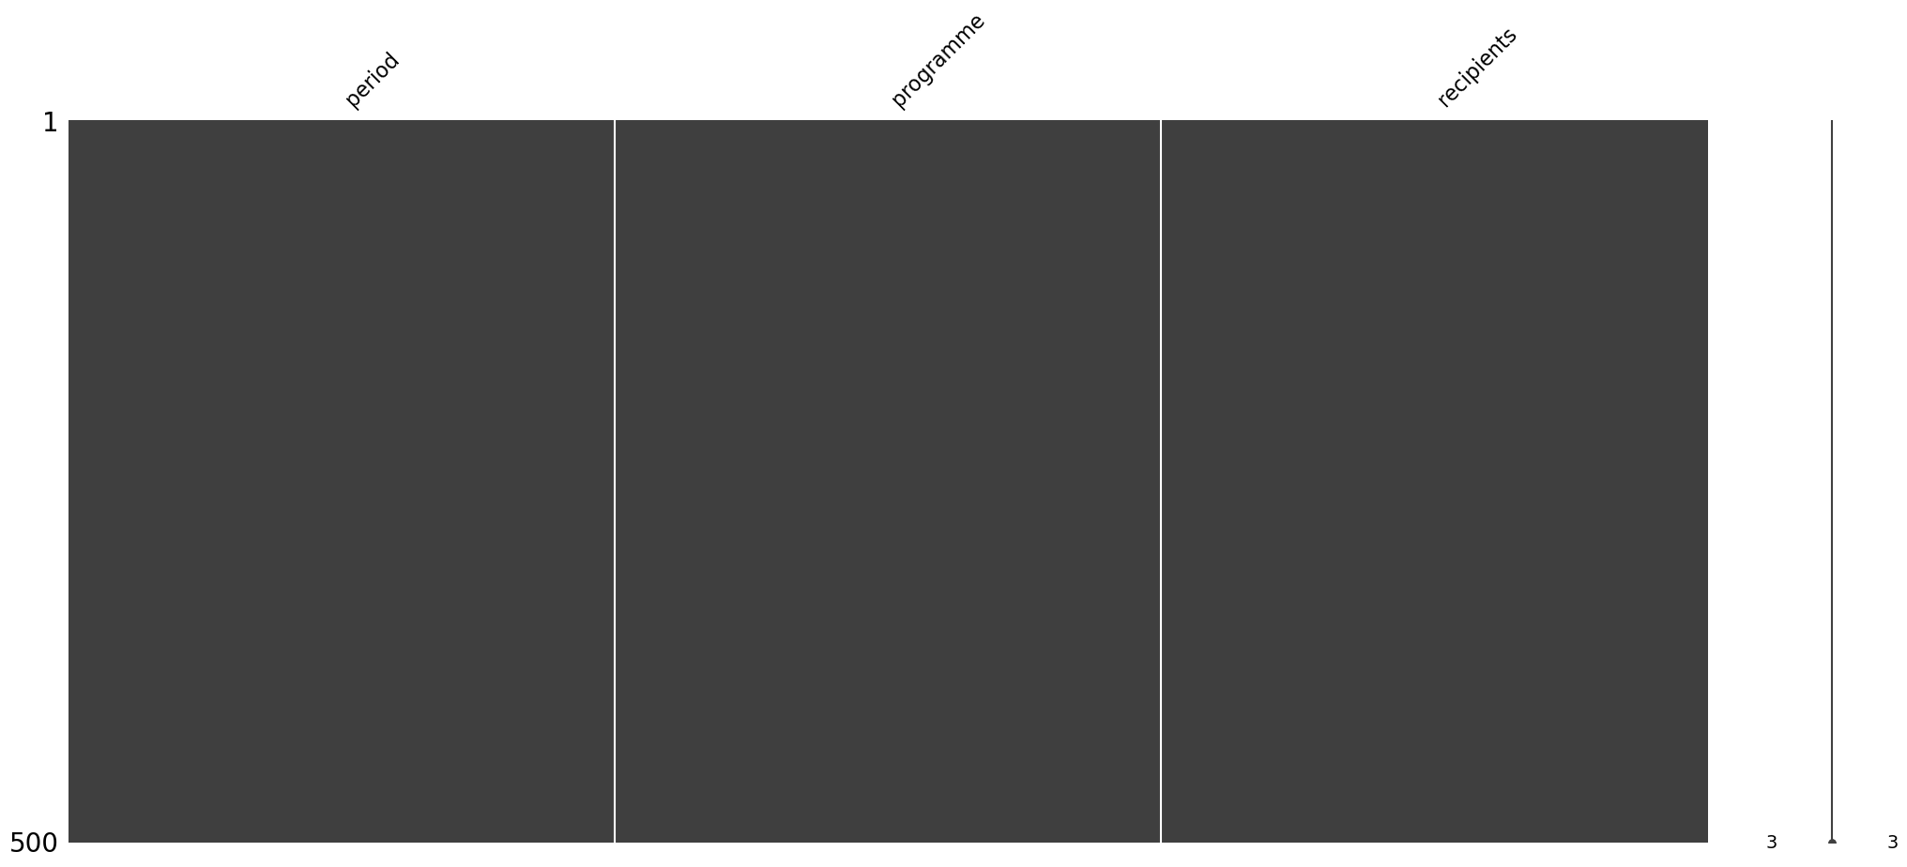
Figure 4 - Visualization of missing values 1

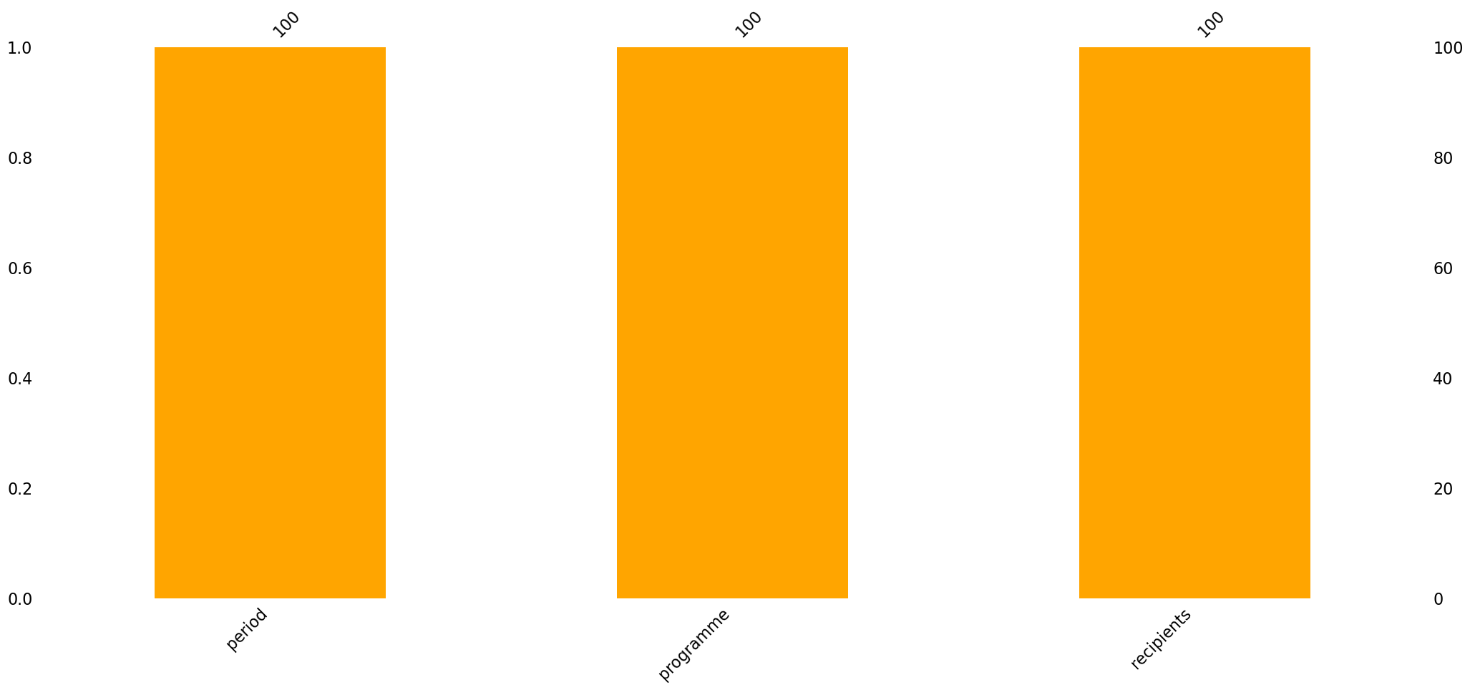
Figure 5 - Visualization of missing values 2

DATA PREPARATION

During the data preparation phase, a sequence of transformations is applied to the data set. These transformations include tasks such as correcting missing values, rectifying errors, incorporating information from different sources and normalising variables. This crucial stage aims to ensure that the data is properly formatted, ensuring that it is ready for effective use in subsequent phases of the project (Avinash, 2021).

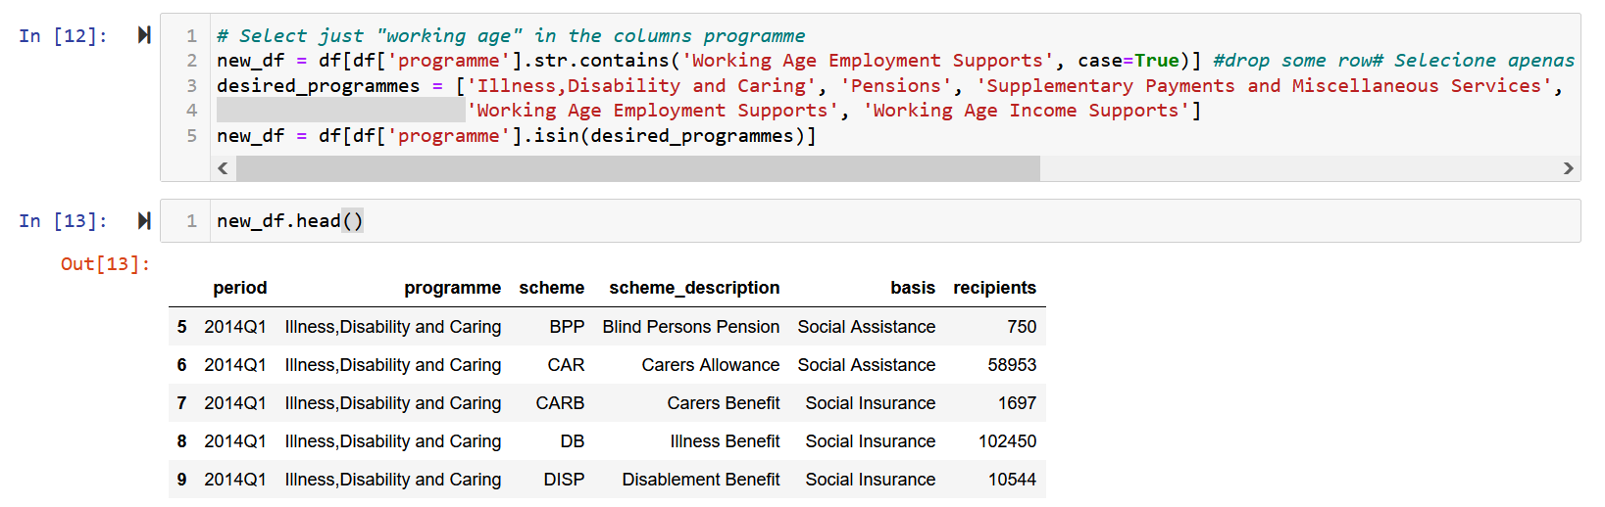
Figure 6 - Select rows

In the figure above, we started by creating a new dataframe, where we selected the required rows within the 'programme' column, actually just excluding the 'Children' row. This code checks that the values in the column are in the list of values. After selecting the display to confirm that the row has indeed been deleted and a new dataframe created.
Then, using '.drop' to drop off the 'scheme' column, which will not affect the data, as it only displays abbreviations of the 'scheme_description' column.

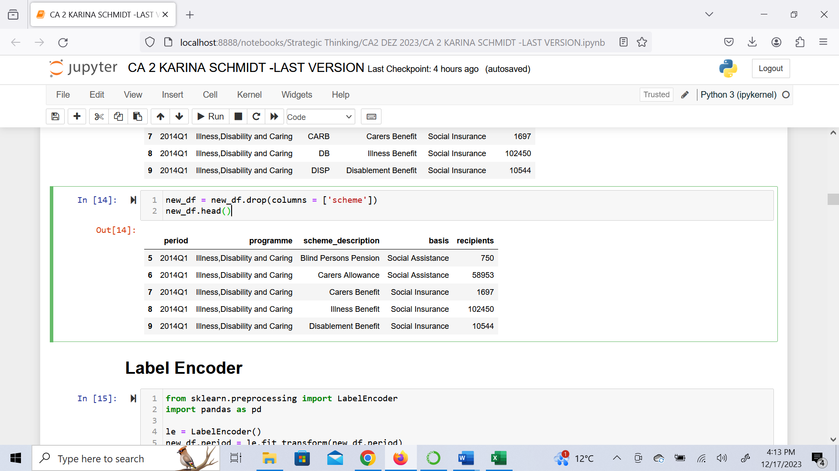
Figure 7 - Drop columns

In the figure below, as there was categorical data, it had to be converted to numerical data in order to work with machine learning, which requires numerical inputs. Thus, when the data is transformed, it is possible to work with machine learning models.

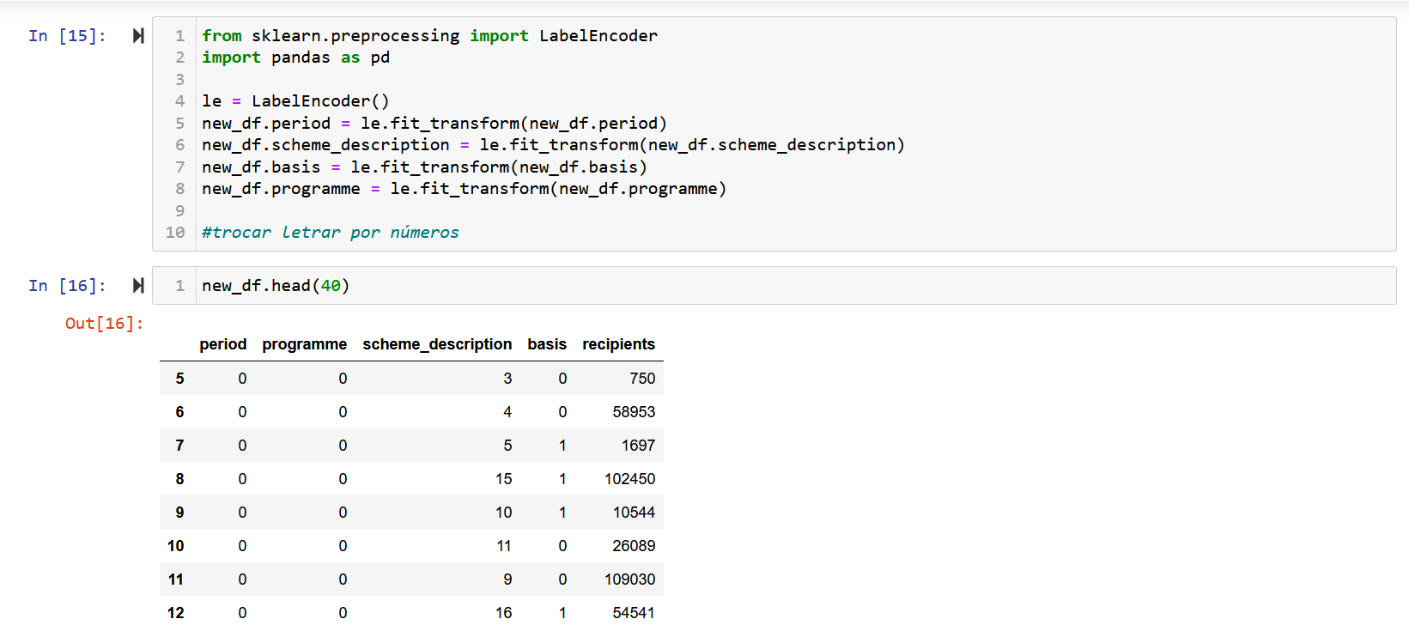
Figure 8 - Label encoder

In this next step, just summarise the statistics for each column selected in the dataset. You can choose the font size, making it easier to visualise and interpret the data.

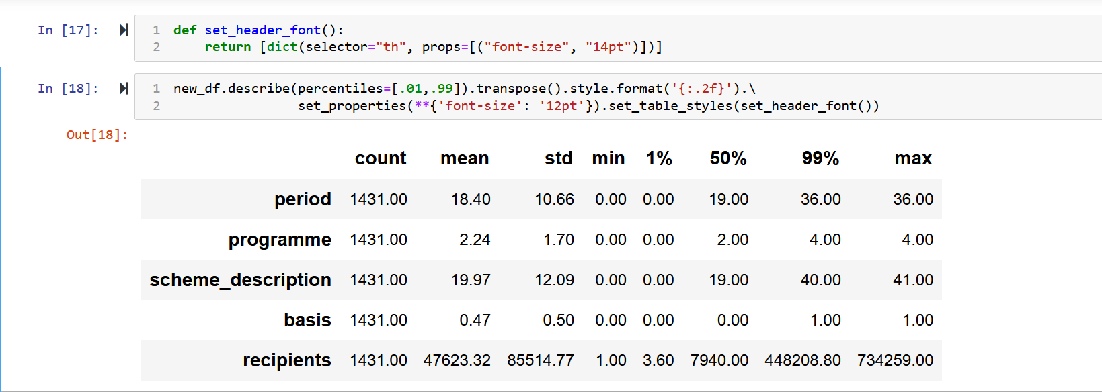
Figure 9 - Summary statistics

MODELING

The modelling phase in machine learning plays a central role in analysing and solving the challenges presented by data sets. It begins with the careful selection of the most suitable model for the data in question, followed by pre-processing, which involves preparing and transforming the data to facilitate the application of machine learning techniques. During modelling, evaluation of the model's performance is conducted using appropriate metrics, allowing adjustments to be made to optimise the model's effectiveness. Once the evaluations are accurate and satisfactory, decisions can be made based on the results obtained. This iterative approach aims to develop robust solutions that meet the specific needs of the dataset being analysed (Jasen, 2020).
Os modelos de machine learning Decision tree, Grid Search CV e Linear Regression are machine learning. Decision Tree are algorithms that organise data in a tree structure, making decisions based on specific characteristics. Each internal node represents a decision with division criteria, and the leaves indicate the final predictions. Its interpretability is an advantage, making it possible to understand the model's decisions. However, the propensity to overfitting is a critical consideration, and it is common to mitigate this with techniques such as ensemble learning. Decision trees are applicable to classification and regression tasks, providing flexibility and versatility in various applications (Lantz, 2015)
Grid Search CV is a technique that searches for the ideal combination of hyperparameters for a model, optimising performance by evaluating various configurations on a predefined grid. Although effective, it can be computationally intensive. Linear regression is a simple statistical model that seeks to model linear relationships between variables, and is interpretable and suitable for regression tasks. However, it is sensitive to outliers and assumes a linear relationship, which can be limiting. Each element plays an important role in different data analysis and modelling scenarios (Giuseppe, 2017).
Decision trees, Grid Search CV and Linear Regression were applied, and both machine learning tests applied to the dataset obtained a value of zero for accuracy, which indicates that all the models are inadequate and/or there was a problem, where the models used failed to show correct predictions. This shows that the dataset may have problems, or the modelling or preparation phase was carried out incorrectly.
The data should be looked at again; there may have been an error in the data preparation, or it may be related to the number of columns or the information contained in them, since the number of columns was few, 6 were worked on, and most of them were categorical data.
The dataset for this project did not contain complex data, which leads us to believe that there could not have been a fault due to the date. Thus causing an error and leading to zero accuracy. By thoroughly reviewing all the data and parameters again, it can be found what may have led to this unsatisfactory result.
When the accuracy is zero, it is necessary to review the data and what would be the best way to implement it again.

EVALUATION

The initial purpose of the project was primarily to examine the subsidy provided by the Irish government to its citizens before, during and after the COVID-19 pandemic, with the prediction that the figures would continue to be higher than those recorded before the crisis, even after companies returned to normal activities.
However, as mentioned earlier, there is an application that needs to be improved, evidenced by an accuracy of zero. This suggests that there are aspects of the data set that need to be revised or even adjusted in the data preparation process. However, it is crucial to emphasise that accuracy should not be considered in isolation; a comprehensive set of factors should be taken into account when assessing model performance.

DEPLOYMENT

So far it had been quite challenging, the data seemed easy to prepare, but when I applied the machine learning models the results didn't come out as expected. I reworked it several times, the first time I got a good accuracy, but when I reworked it because I thought it was wrong, I couldn't get the expected result. I tried very hard to understand what was going on, but I came to the conclusion that perhaps because the dataset contained few columns, and with similar data (republished), this may also have helped to arrive at this unsatisfactory result.

Top of Form

REFERENCES

Avinash Navlani, Fandango, A. and Idris, I. (2021). Python Data Analysis. Packt Publishing Ltd.

Birmingham: Packt Publishing. Available at: https://search.ebscohost.com/login.aspx?direct=true&db=e250xww&AN=2725992&site=eds-live&scope=site (Accessed: 17 December 2023).

Bargain, O. and Doorley, K. (2016). The Effect of Social Benefits on Youth Employment: Combining RD and a Behavioural Model. SSRN Electronic Journal, [online] 2016-12. Doi: https://doi.org/10.2139/ssrn.2835473.

Brett Lantz (2015) Machine Learning with R : Expert Techniques for Predictive Modeling to Solve All Your Data Analysis Problems. Birmingham: Packt Publishing. Available at: https://search.ebscohost.com/login.aspx?direct=true&db=e250xww&AN=1048220&site=eds-live&scope=site (Accessed: 15 December 2023).

Commission on Taxation and Welfare Secretariat (2021). Introduction to the Irish Social Protection system. [online] Available at: 20210618_P_IntroductiontotheIrishSocialProtectionSystem_Final [Accessed 23 Oct. 2023].

Giuseppe Bonaccorso 2017, Machine Learning Algorithms : Build Strong Foundation for Entering the World of Machine Learning and Data Science with the Help of This Comprehensive Guide, Packt Publishing, Birmingham, UK, viewed 16 December 2023, <https://search.ebscohost.com/login.aspx?direct=true&db=e250xww&AN=1562685&site=eds-live&scope=site>.

Keane, C., Doorley, K. and Tuda, D. (2021). COVID-19 and the Irish Welfare System Evidence for Policy. Budget Perspectives 202102, [online] Paper 2. DOI: https://doi.org/10.26504/bp20222.

Maddux, D.J. and Maddux, R.B. (2010) Ethics in Business : Manage with Authority and Fairness. [Rochester, NY?]: Axzo Press (Crisp Fifty-Minute Series). Available at: https://search.ebscohost.com/login.aspx?direct=true&db=e020mww&AN=383339&site=eds-live&scope=site (Accessed: 17 December 2023).

OECD (2019). Demography - Working age population - OECD Data. [online] OECD. Available at: https://data.oecd.org/pop/working-age-population.htm.
Stefan Jansen (2020) Machine Learning for Algorithmic Trading : Predictive Models to Extract Signals From Market and Alternative Data for Systematic Trading Strategies with Python, 2nd Edition. Birmingham, UK: Packt Publishing. Available at: https://search.ebscohost.com/login.aspx?direct=true&db=e020mww&AN=2557666&site=eds-live&scope=site (Accessed: 12 December 2023) .‌
World Health Organization (2023). WHO Coronavirus (COVID-19) Dashboard. [online] covid19.who.int. Available at: https://covid19.who.int/?mapFilter=deaths [Accessed 10 Oct. 2023].

